GRAMONNATI TRUST
Website Content & Strategy Blueprint — v2
Our Full Journey (2017-Present) | Page-by-Page Website Content | The Woloo Programme | Refreshed Vision & Mission | Roadmap to a World-Class Website

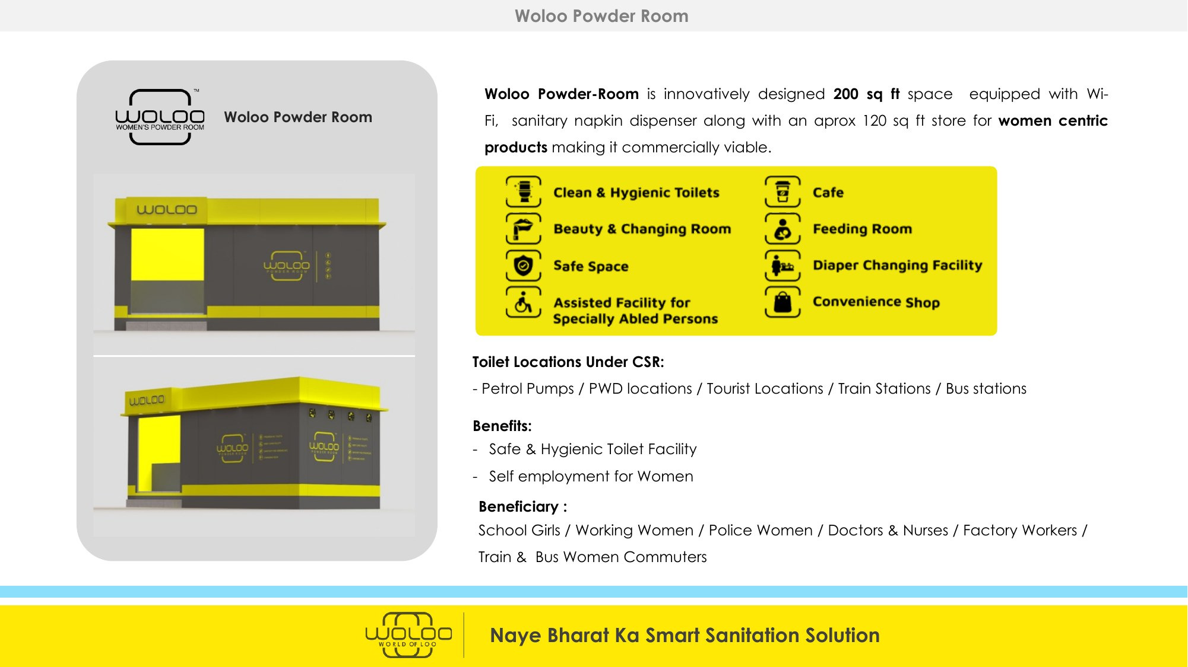

Prepared for Maj. Ved Prakash Sharma (Retd.), Founder & Chairman, Gramonnati Trust
Revised June 2026 | www.gramonnati.org | info@gramonnati.org
This revision consolidates the Trust's full history (from the 2017-18 and 2018-19 Annual Reports) into one chapter,
and reorganises all website content into clean, one-chapter-per-page sections for direct handover to the website developer.

How This Document Is Organised
Each chapter below corresponds to exactly one page of the new website. Use this document as a direct content source — copy each chapter into its matching page template.
Chapter | Website Page
1 | Home
2 | About Us (Our Story, Vision & Mission, Governance)
3 | Our Journey — From Rural Entrepreneurship to Smart Sanitation (2017-Present)
4 | The Woloo Programme (Pondicherry, Tamil Nadu & Bengaluru)
5 | Clean & Divine India — The Guilt-Free Travel Initiative
6 | Travel Partnerships (incl. MakeMyTrip CSR Proposal)
7 | Impact & Transparency
8 | Partner With Us / Get Involved
9 | Contact Us
Annexure A | Making the Website World-Class — Recommendations

We have also attached the presentation on Woloo– please use it liberally for designing the website

CHAPTER 1
HOME
Goal: in 5 seconds, a CSR manager or crowdfunding donor should understand who we are, what we build, and why it's credible. Every element below should drive toward a donation, partnership enquiry, or deeper exploration.
Hero Section
Headline:
“Dignity, Delivered. One Powder Room, One Pellet Plant, One Self-Reliant Community at a Time.”
Sub-headline:
Gramonnati Trust builds smart sanitation, circular-waste and livelihood infrastructure across India — staffed by women, war widows and ex-servicemen families, and built for transparent CSR and crowdfunding partnership.
Primary CTAs:
- Partner With Us (CSR / Corporate)
- Donate / Crowdfund a Unit
- See Our Impact
Visual: rotating hero imagery/video of an operating Woloo unit, a woman host at work, and a community training session.
Impact Strip (animated counters)
Metric | Current | Headline for Site
Years of grassroots work | 2017-Present | 8+ years on the ground
Woloo units operational (network-wide) | 46 | 46 Smart Hygiene Units Live
Women & veterans trained/employed | 1,03,909 | Over 1 Lakh Women & Veterans Engaged
Rainwater harvesting systems built (J&K) | 5+ | Water Security Delivered in Border Villages
Border-district schools reached (Vidya-Jyoti) | 4+ | Digital Classrooms in J&K
Registrations | 12AA / 80G / CSR-1 | Fully CSR & Tax-Deduction Eligible

‘What We Do’ — Four Pillars (icon cards)
- Smart Sanitation — Woloo Powder Rooms for dignity, hygiene and women's safety
- Circular Economy — Waste-to-Pellet (RDF) units turning waste into revenue
- Rural & Women's Livelihoods — entrepreneurship, training and dignified employment
- Technology & Transparency — live dashboards, audited reporting, BRSR/SDG alignment
Featured Programmes (cards)
The Woloo Programme
Partnering with Woloo to bring smart, women-run sanitation infrastructure to Bengaluru, Puducherry and Tamil Nadu's temple towns — launching shortly. [Learn More →]
Clean & Divine India
Turning every traveller's ₹10 into clean, dignified infrastructure at India's most-visited destinations. [Learn More →]
Travel Partnerships
A ready-to-integrate CSR model for OTAs, airlines and hospitality brands. [Learn More →]
Our Journey
From rainwater harvesting in the hills of Rajouri-Poonch to smart sanitation infrastructure nationwide — eight years of grassroots transformation. [Read Our Story →]
Why Partner With Gramonnati
- Fully compliant — 12AA, 80G and CSR-1 registered; Schedule VII eligible
- A track record spanning rural education, water security and livelihoods since 2017
- Transparent, audited, dashboard-driven reporting
- A unique, dignity-first employment model — ex-servicemen families, war widows, women's SHGs
Recognition & Network
Logo strip: Woloo, FuelADream, TERI, Indian Army (Sadbhavana / Mission Samriddhi partnerships), and CSR/corporate partners as they onboard.
Final CTA Banner
“Every contribution — ₹10 or ₹10 Crore — builds dignity somewhere in India.”
[Donate Now] [Become a CSR Partner] [Explore Our Projects]

Why Partner With Gramonnati
- Fully compliant CSR vehicle — 12AA, 80G, CSR-1, Darpan
- Eight years of on-ground delivery, from rural J&K to national sanitation infrastructure
- A distinctive, story-able workforce model built around dignity and service
- Transparent, audited, dashboard-driven impact reporting

CHAPTER 2
ABOUT US
Our Story
Gramonnati Trust was founded on 5th October 2017 in Puducherry by Maj. Ved Prakash Sharma (Retd.) and a fellow Cisco Systems colleague, both leaving stable corporate careers to pursue social entrepreneurship. The mission they set themselves was audacious: develop 10,000 rural entrepreneurs within five years.
That mission first took root in the border districts of Rajouri and Poonch in Jammu & Kashmir — through digital classrooms, rainwater harvesting, and entrepreneurship training delivered in partnership with the Indian Army and TERI. Since 2022, Gramonnati has evolved that same grassroots discipline into a new frontier: smart sanitation and circular-waste infrastructure through the Woloo Programme and Clean & Divine India — built, once again, by the people most often overlooked: women, war widows, and ex-servicemen families. Read the full story in Chapter 3 — Our Journey.
On ‘Deep Impact Over the Coming Years’
Gramonnati's history shows a consistent pattern: start small and local (one Kendra, one rainwater tank), prove the model rigorously, then scale through partnership (Indian Army, TERI, Woloo, AWPO). The same discipline should frame every new initiative — Bengaluru and Pondicherry are not isolated campaigns, but the next chapter of an eight-year track record of building things that last.
“We started with one village. Today, we're building the infrastructure of dignity for a billion Indians — one rainwater tank, one classroom, one Powder Room at a time.”
Vision
“To make every community we work with self-reliant — in water, in sanitation, in livelihoods, and in waste.”
Mission
- Dignified Livelihoods — for women, war widows and ex-servicemen families
- Smart Sanitation — technology-enabled hygiene infrastructure wherever needed
- Circular Economy — converting waste into resource and revenue
- Rural & Women's Entrepreneurship — self-sustaining, community-owned micro-enterprises
- Technology, Transparency & Partnerships — live data, audits, and open collaboration
Governance & Credentials
Founded | 5th October 2017, Puducherry, as a Public Charitable Trust
Founder & Chairman | Maj. Ved Prakash Sharma (Retd.)
PAN | AACTG8992R
12AA | Registered — income-tax exempt
80G | Valid in perpetuity from AY 2019-20 — 50% tax deduction for donors
CSR Registration | CSR-1 (Reg. No. CSR00017701) — eligible for corporate CSR funding
Area of Operation | Pan-India, headquartered in Puducherry; legacy programmes in J&K
Audit | Independent annual financial audit

Trustees:
Shrihari Allangala
Trustee – Finance & Strategy
30+ years in investment banking and private equity. Strengthens Gramonnati for large CSR partnerships.
Maj. VP Sharma (Retd.)
Founder & Managing Trustee
Retired Army Major. Founded Gramonnati 2017. Architect of the Woloo-Gramonnati partnership. Champion of veteran welfare.
Ayushi Sharma
Trustee – Women Empowerment
Leads all women empowerment programmes. Manages field operations and the Woloo women-operator model.
Brig. Atul Sharma (Retd.)
Trustee – Armed Forces Coordination
35 years in Defence ICT. B.Tech. Expertise in large-scale programme management and governance.
Shyam Kaluve
Trustee – Technology
30+ years in Technology Industry. Deep experience in CSR Projects

CHAPTER 3
OUR JOURNEY — FROM RURAL ENTREPRENEURSHIP TO SMART SANITATION (2017-PRESENT)
Source: Gramonnati Trust Annual Reports FY2017-18 and FY2018-19, plus subsequent programme documentation. This chapter consolidates the Trust's full track record into one website page — ‘Our Journey’ — with supporting photographs from the field.
2017-18 — The Foundation Year
Gramonnati Trust was born when its co-founders left their corporate careers at Cisco Systems in 2017 to pursue social entrepreneurship, setting themselves the goal of developing 10,000 rural entrepreneurs within five years. The Trust based itself in Puducherry and chose to begin its grassroots work in the border districts of Rajouri and Poonch, Jammu & Kashmir.
The Udyam Programme
Udyam — Gramonnati's flagship path-to-entrepreneurship programme for youth, women and ex-soldiers — launched on 26th January 2018 with the opening of the Jabalpur Gramonnati Kendra at LS Jha Model School, Jabalpur. Twenty aspirational NCC cadets from nearby villages were shortlisted for foundational training in digital literacy, financial literacy and self-employment skills, supported by broadband internet, video-conferencing and trainers from Prep My Skills.
- Two trainees, Sumita and Sunmeet, were groomed as Spoken English instructors and went on to design and deliver a 50-hour Spoken English course — first for local children, and later for soldiers of the 1 Signal Training Centre, Jabalpur.
- Key learning: changing the mindset of youth and their families toward entrepreneurship — and giving young people clearer guidance on their future options — emerged as the programme's central, ongoing challenge.
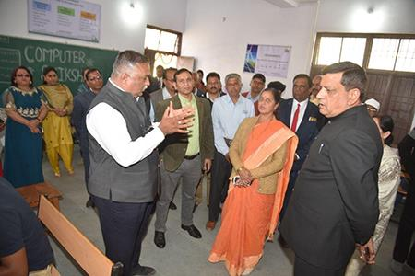 | 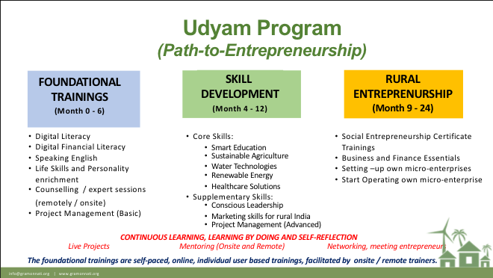
Left: Inaugurating the Jabalpur Gramonnati Kendra, the birthplace of the Udyam Programme. Right: The multi-stage Udyam path-to-entrepreneurship model.

2018-19 — Deepening Impact in J&K
In its second year, Gramonnati expanded from a single Kendra into a multi-programme presence across the border districts of Rajouri and Poonch, working closely with the Indian Army and TERI, New Delhi.
Vidya-Jyoti — Transforming Rural Education
Vidya-Jyoti brought technology-enabled learning to rural schools in J&K's border districts — combining high-quality video content in Maths, Science and English, live digital classes over video-conference, and structured teacher training. In September 2018, the programme launched as a pilot in four schools run by the Indian Army, with two schools fully adopting the multimodal content into daily teaching. Six teachers from three border-district schools were sent on a training tour to the Agastya International Foundation, organised with the Indian Army's support.
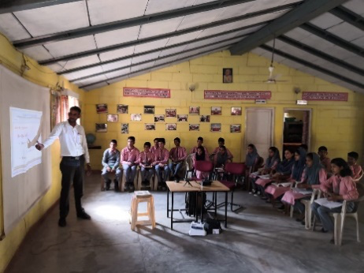
A Vidya-Jyoti digital classroom session in a border-district school, Rajouri-Poonch, J&K.
Jal Sanchaya — Solving the Water Problem in Border Districts
Jal Sanchaya tackled chronic water scarcity in the upper reaches of the Rajouri-Poonch hills through low-cost rainwater harvesting — developed in close partnership with TERI, New Delhi, and designed to also build local rural entrepreneurs in water solutions. After identifying five priority locations with TERI and local Army units, the first rooftop rainwater harvesting system was completed in October 2018 at Model Academy, Sagra, Poonch district — built in just three days and filled to capacity within five days of monsoon rain. Four more systems followed across the region, training 6-8 local people in installation at each site.

The Jal Sanchaya rooftop rainwater-harvesting model, developed with TERI, New Delhi.
Sarpanch Yatra — Mission Samriddhi
In consultation with the Indian Army (under its Sadbhavana programme for social harmony) and the civil authorities of Rajouri and Poonch, Gramonnati and Mission Samriddhi jointly designed an educational and experiential tour for 20 sarpanches (panchayat leaders) to India's model villages. The Yatra aimed to upgrade panchayat leadership skills across health, education, livelihood and empowerment; build rural entrepreneurship at the village level; and align local farming practices with organic agriculture protocols — through sessions on design thinking, grassroots leadership, and profitable organic farming on small landholdings.
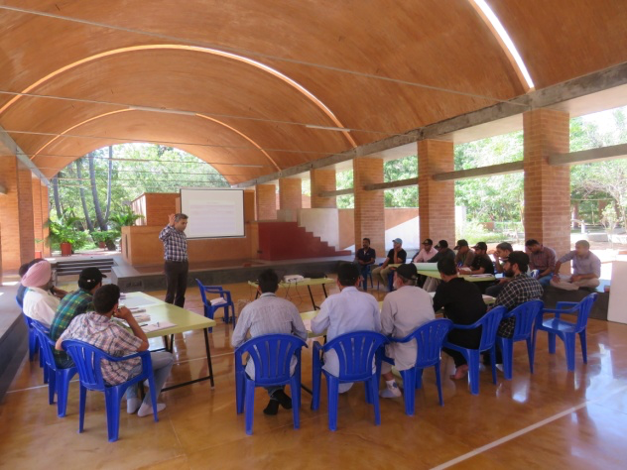
Panchayat leaders from Rajouri and Poonch districts at a Sarpanch Yatra training session under Mission Samriddhi.

2022-2025 — Ravikiran Dehydration Project
Please see HTML File with images in the folder “Project Ravikiran”

2022-Present — The Smart Sanitation Pivot
Building on eight years of rural development experience, Gramonnati Trust extended its mission into smart sanitation and circular-waste infrastructure — partnering with Woloo and launching Clean & Divine India. The same workforce philosophy that powered the Udyam Programme — dignity-first livelihoods for under-served communities — now anchors the Woloo Programme's staffing model of ex-servicemen families, war widows and women's Self-Help Groups. See Chapters 4 and 5 for details.
Looking Back, Looking Forward
From a single Kendra in Jabalpur and rainwater tanks in the hills of Poonch, to a nationally scaling smart-sanitation movement — Gramonnati's journey has been one of consistent grassroots discipline: identify a real, local problem; build a simple, technology-enabled solution; train and employ the community itself to run it; and measure the outcome honestly. That discipline is the foundation for everything that follows in this document.

CHAPTER 4
THE WOLOO PROGRAMME
Note on positioning: Woloo units have not yet been deployed under Gramonnati — this page should be written and launched in a ‘coming soon’ voice that builds anticipation and invites early partnership, not in the past tense.
Hero
Headline:
“Coming Soon: Smart, Women-Run Sanitation — Starting in Bengaluru.”
Sub-headline:
Gramonnati Trust has partnered with Woloo — India's smart-hygiene platform (Shark Tank India 2022) — to bring dignified, technology-enabled sanitation to Bengaluru, Puducherry and Tamil Nadu's temple towns. Our first units launch shortly.
[CTA] Be a Founding Partner | [CTA] Get Notified at Launch
Our Partnership With Woloo
Gramonnati Trust is proud to partner with Woloo — the country's only integrated smart-hygiene platform, combining clean, pay-and-use sanitation with women's safe spaces, café and retail convenience, and IoT-enabled hygiene monitoring through the Loo-Locator app. Through this partnership, Gramonnati will deploy and operate Woloo's ‘Powder Room’ units across our priority geographies, run entirely by the communities we exist to serve.
We have not yet broken ground — and we are deliberately telling that story honestly. Our first project is about to come up in Bengaluru, and we are inviting partners to join us at the ground floor of this initiative.
Where We're Headed First — Bengaluru (100 Units)
Bengaluru is our first city of deployment. Plans are underway to bring Woloo's smart Powder Rooms to the city's fuel retail outlets, transit hubs, religious sites and markets — closing a real, daily gap for working women, commuters and market-goers. Updates on confirmed sites and launch timelines will be shared here as the project breaks ground.
Our Next Step — 100 Units Across Pondicherry & Tamil Nadu's Temple Towns
Once Bengaluru Project starts, Gramonnati is planning a 100-unit Woloo deployment across Puducherry and major Tamil Nadu temple towns — bringing safe, dignified sanitation to some of India's highest-footfall pilgrimage and heritage destinations.
- Puducherry — Beach Boulevard / White Town heritage zone, the Auroville wellness corridor, and the Chennai-Puducherry ECR corridor.
- Tamil Nadu temple towns — including destinations such as Madurai, Tirupati, Trichy, Rameswaram, Thanjavur, Chidambaram and Kanyakumari, chosen for their year-round pilgrim and tourist footfall.
The goal: prove a replicable Woloo model in Puducherry, then scale it across Tamil Nadu's temple-town circuit as a template other Tier-II/III pilgrimage cities can adopt.
Who Will Run These Units — Our Workforce Commitment
Every Woloo unit under Gramonnati will be staffed by the people who have earned, and too rarely received, dignified employment: family members of ex-servicemen and war widows. This is a direct extension of the same dignity-first employment philosophy that has guided Gramonnati since the Udyam Programme (see Chapter 3).
- City Leaders and Cluster Heads — preference to retired women officers and war widows with leadership experience
- Retail, café and cleaning staff — drawn from ex-servicemen families, war widows, and local women's Self-Help Groups
Our Partnership With Army Welfare Placement Organisation (AWPO) and Army Wives AWWA
To identify and onboard the right members of the ex-servicemen community for these roles, Gramonnati is working with AWPO and AWWA (Army Wives Welfare Association) — ensuring that recruitment reaches genuine ex-servicemen families and war widows with the support and verification this workforce model requires.
Partner With This Programme — Founding Tiers
Because this programme has not yet launched, early partners have a rare opportunity: to help shape and name India's next Woloo deployment from day one.
Built for ESG & CSR Reporting From Day One
- Schedule VII compliant (Companies Act 2013) — sanitation, health, women's empowerment, livelihood
- 80G — 50% tax deduction on donations; CSR-1 registered for corporate CSR eligibility
- BRSR-ready impact reporting designed in from the start
- A live launch dashboard — tracking site readiness, construction progress, and go-live dates
Stay Connected
- 1. Register your interest as a founding partner.
- 2. We'll share confirmed sites and timelines as Bengaluru and Pondicherry plans firm up.
- 3. Be first to know when our first unit goes live.

CHAPTER 5
CLEAN & DIVINE INDIA
The Guilt-Free Travel Initiative
Hero
Headline:
“Travel Guilt-Free. Leave India Cleaner Than You Found It.”
Sub-headline:
For every traveller, a contribution of just ₹10 funds real sanitation and waste-management infrastructure at the destinations India's tourists love most.
[CTA] Partner Your OTA / Travel Brand | [CTA] Learn the ₹10 Model
The Problem We're Solving
India welcomes over 1.44 billion domestic and international pilgrim and leisure visits a year — yet 60%+ of high-footfall tourist and religious sites lack adequate sanitation and waste-management infrastructure. The result: a tourism-waste nexus that damages India's heritage sites, public health, and global image, while costing the economy an estimated $53.8 billion in lost tourism potential. Clean & Divine India turns every traveller into part of the solution — at near-zero cost to them.
Two Pillars
Pillar 1 — Smart Sanitation (Woloo Powder Rooms)
Clean, safe, pay-and-use sanitation facilities placed at the tourism sites that need them most — staffed by local women and run as micro-enterprises.
Pillar 2 — Waste-to-Resource (Pellet/RDF Units)
Waste-to-Pellet (RDF) plants convert local solid waste into refuse-derived fuel — reducing landfill burden at tourist destinations while creating a revenue stream that funds ongoing operations.
The ₹10 Mechanism
Built for integration with Online Travel Agents (OTAs), airlines, hotels and booking platforms via a simple EPS API: at checkout, travellers are offered (opt-in or opt-out) a ₹10 “Guilt-Free Travel” contribution. At scale, even modest adoption rates generate substantial, predictable funding.
Implementation Roadmap
Phase | Focus
Phase 1 — Foundation | Pilot integration with 1-2 travel partners; first units deployed at flagship pilgrimage/tourism sites
Phase 2 — Scale | Expand partner network (OTAs, airlines, hotel chains); roll out units across top 20 tourism circuits
Phase 3 — Sustain | Self-sustaining unit operations via retail/advertising revenue; reinvest surplus into new sites

Alignment
- Swachh Bharat Mission 2.0 — sanitation and waste management at scale
- UN SDGs 3, 5, 6, 8, 11, 12, 17
- ESG/BRSR reporting for travel-sector corporates
Why Travel Partners Choose Clean & Divine India
- Near-zero customer friction — a ₹10 opt-in, seamlessly embedded at checkout
- Tangible, location-linked impact your customers can see and feel proud of
- Ready-made ESG/CSR storytelling for your brand and investor reporting
- Live dashboard showing funds raised, units built, and people served

CHAPTER 7
IMPACT & TRANSPARENCY
Hero
Headline:
“See Exactly Where Every Rupee Goes.”
Sub-headline:
Embed a live dashboard widget here once the Woloo Bengaluru/Pondicherry units go live — auto-refreshing counters for footfall, revenue and employment.
Aligned With the UN Sustainable Development Goals
SDG | Focus Area
SDG 1 | No Poverty — stable incomes for women operators
SDG 3 | Good Health & Well-being — hygienic sanitation access
SDG 4 | Quality Education — Vidya-Jyoti digital classrooms
SDG 5 | Gender Equality — women-led infrastructure and safety
SDG 6 | Clean Water & Sanitation — Jal Sanchaya and Woloo
SDG 8 | Decent Work & Economic Growth
SDG 11 | Sustainable Cities & Communities
SDG 12 | Responsible Consumption & Production — waste-to-resource
SDG 17 | Partnerships for the Goals — Army, TERI, Woloo, AWPO

Governance, Compliance & Audit
- Registered under the Indian Trusts Act — 12AA and 80G certified
- CSR-1 registered — eligible for corporate CSR funding under the Companies Act, 2013
- Annual independent financial audit
- Field verification visits available on request for CSR partners
- BRSR-ready impact data for listed-company reporting
Downloads
- [Download] Annual Reports (FY2017-18, FY2018-19 and onward)
- [Download] 12AA / 80G / CSR-1 Certificates
- [Download] Audited Financial Statements
- [Download] Latest Impact Report

CHAPTER 8
PARTNER WITH US
Hero
Headline:
“However You Give, It Builds Dignity.”
Sub-headline:
Whether you're a corporate CSR team, a travel platform, or an individual donor — there's a way to be part of this that fits you.
For Corporates — CSR Partnerships
Gramonnati Trust is CSR-1 registered, 12AA and 80G certified — making every contribution fully eligible under Schedule VII of the Companies Act, 2013, with 50% tax deduction under Section 80G.
For Travel & Hospitality Brands
Integrate the Clean & Divine India ₹10 Guilt-Free Travel contribution into your booking flow via our EPS API — see Chapter 6, Travel Partnerships, for details.
For Individuals — Crowdfunding & Donations
As Woloo units launch in Bengaluru and Pondicherry, campaigns will run on FuelADream, India's trusted crowdfunding platform for social causes. Your contribution — large or small — will be acknowledged on our Gratitude Wall and is eligible for an 80G tax receipt.

[CTA] Register Interest | [CTA] Set Up a Recurring Gift
For Volunteers & Supporters
- Spread the word — follow and share our campaigns
- Corporate volunteering — team visits once units are operational
- Skilled volunteering — design, communications, data and impact-measurement support
Tax Benefits at a Glance
- 80G — 50% deduction on donations for Indian taxpayers
- CSR-1 registered — fully eligible for corporate CSR spend
- 12AA — income-tax exempt status for the Trust

CHAPTER 9
CONTACT US
Hero
Headline:
“Let's Build This Together.”
Sub-headline:
Whether you're exploring a CSR partnership, a crowdfunding contribution, media enquiry, or volunteering — we'd love to hear from you.
Reach Us
Channel | Details
General enquiries | info@gramonnati.org
Partnerships & CSR | ved@gramonnati.org
Phone (Mobile) | +91 80959 99776
Website | www.gramonnati.org

Visit Us
Insert registered office address from Trust Profile.
Puducherry, India
Contact Form Fields
- Name
- Organisation (optional)
- Email
- Phone
- I'm interested in: [dropdown — CSR Partnership / Crowdfunding & Donations / Travel Partnership / Media & Press / Volunteering / Other]
- Message
Follow Us
Social media icon row — LinkedIn, Instagram, Facebook, YouTube, X.

Annexure A
MAKING THE WEBSITE WORLD-CLASS
A handful of features consistently separate a good NGO website from a world-class one — especially for organisations courting CSR funders and global crowdfunding audiences.
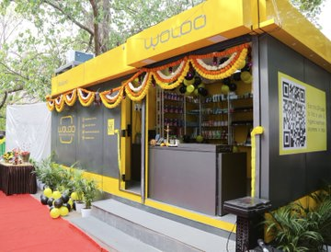
A Woloo Powder Room unit in operation elsewhere in the network — real photography like this, plus archival photos from our J&K programmes, should anchor the site's visual identity.
1. Live Impact Dashboard
A real-time (or daily-refreshed) counter showing units operational, footfalls served, women employed, and funds raised — embedded on the homepage and Impact page. Until Bengaluru/Pondicherry units go live, this can show network-wide Woloo numbers with a clear ‘our units coming soon’ note.
2. Interactive India Map
A clickable map showing every past and current project location — Rajouri-Poonch (J&K legacy programmes), Bengaluru and Pondicherry (Woloo, launching), and national Clean & Divine India sites — filterable by status (live / under construction / planned).
3. Video Storytelling
Short (60-90 second) videos: archival footage from the J&K Kendra and rainwater-harvesting work, plus the Bengaluru/Pondicherry Woloo launch as it happens. Video converts CSR and crowdfunding visitors far better than text alone.
4. Donor & CSR Recognition Wall
A persistent, searchable digital ‘Gratitude Wall’ — every sponsor, donor and CSR partner listed with their tier, linked to the unit(s) they funded.
5. Embedded Crowdfunding Widget
Direct FuelADream campaign embeds on relevant project pages, with live progress bars, once Bengaluru/Pondicherry campaigns launch.
6. Downloadable Transparency Pack
One-click access to 12AA/80G/CSR-1 certificates, audited financials, and both annual reports (FY2017-18, FY2018-19, and onward) — pre-packaged for CSR due-diligence teams.
7. Blog / News / Press Room
Regular updates on Bengaluru/Pondicherry launch milestones, partner announcements (Woloo, AWPO), and field stories — improves SEO and gives journalists a ready resource.
8. Multilingual Support
Hindi, Tamil and regional languages (especially for Pondicherry/Tamil Nadu and Bengaluru/Karnataka audiences), alongside English.
9. Accessibility & Performance
WCAG-compliant design (screen-reader friendly, sufficient colour contrast — especially given the green/gold palette), fast mobile load times, and SEO-optimised metadata on every page.
10. Volunteer & Careers Portal
A simple portal for volunteer sign-ups and future job openings at Woloo units — reinforcing the livelihoods narrative and building a talent pipeline ahead of launch.
11. Photo & Video Gallery
A growing, well-tagged gallery spanning J&K archival photos through to new Woloo units — organised by programme and location.
12. Newsletter & Email Capture
A simple sign-up for quarterly impact updates and Bengaluru/Pondicherry launch news — nurtures CSR leads and crowdfunding donors over time.
13. Live Chat / Chatbot
A lightweight chatbot to answer common CSR/donor questions (tax benefits, partnership tiers, launch timelines) instantly, with hand-off to the team for complex enquiries.
14. Partner Logo Carousel
A rotating strip of partners — Woloo, AWPO, TERI, Indian Army programmes, and CSR sponsors as they onboard — builds instant credibility for new visitors.
15. Security & Privacy
SSL, secure donation/payment flows, and a clear privacy policy — essential for any site handling donor information and payments.

Closing Note
This blueprint is designed to be handed directly to a website development team — every chapter above maps one-to-one to a website page. Tables, figures and scenario numbers marked in grey/italic should be finalised against source documents before publishing.
Open items before this goes to the developer:
- Registered office address for Chapter 9 (Contact Us)
- Confirmed Bengaluru and Pondicherry site lists and launch dates, once finalised
Next steps we recommend:
- Finalise the sitemap and get sign-off from the Trust's leadership
- Commission professional photography/video once the first Bengaluru or Pondicherry unit breaks ground
- Build the live impact dashboard as a shared data source feeding both the website and CSR reports
- Develop the site in phases: Home + About + Our Journey + Impact first (CSR-facing), then the Woloo/Clean & Divine/Travel Partnerships pages, then Partner/Contact

